EsaBend IoT ModBusTCP P2
NOTE 1: Some of the features described may not be present on older versions of EsaBend. NOTE 2: ver. only 58.1 of EsaBend contains all the features described.

Description
EsaBend is enabled to make a series of data visible and receive a series of data and commands from an external supervisor which can reside on the same PC as EsaBend or on a different PC.
To make a series of data visible and receive data and execute commands EsaBend uses a ModBusTCP server; the supervisor must therefore be a ModBusTCP client that reads data and transmits data and commands via the appropriate ModBus registers.

Enable feature
The EsaBend ModBusTCP server service is paid feature and must be enabled via KvOption: if the checkbox in "MODBUS TCP" is enabled, the service has been enabled.
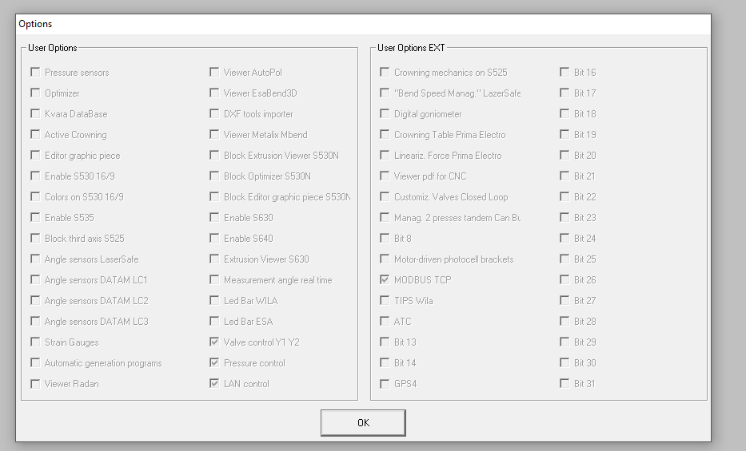

Copy file from: C:\Esabend\Kvara\Exe\NewXMLModBus\ServerModbus.xml To
C:\Esabend\Kvara\Exe\ServerModbus.xml Open ServerModbus.xml and configure correct IP in:
<IPAddr>127.0.0.1</IPAddr>

In Basic Parameter\Tandem Evolved set the parameter to 2 TE3
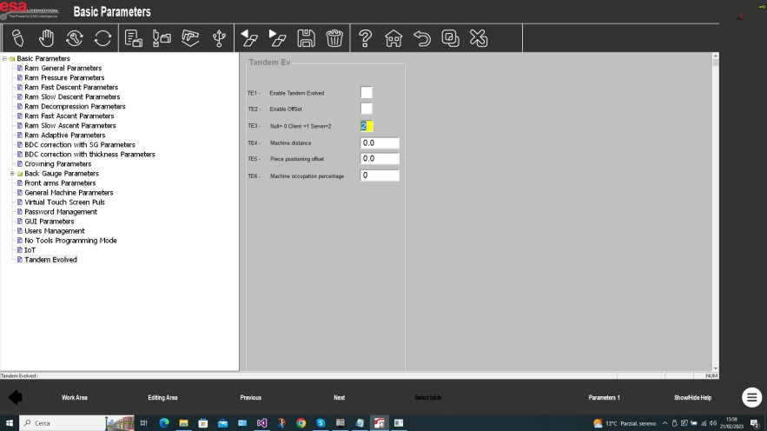
To check if the ServerModBusTCP is active, check that the 2 messages have been printed in PLC Menú:
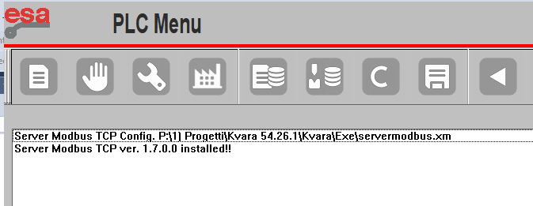
The commands arriving from the supervisor are "heard" by EsaBend from the "Classic" numerical setting pages of the work program.

- SupervisorClientModBusTCP<->EsaBend architecture
The components that make up the system are:
  - EsaBend + ServerModbus.dll
  - Supervisor + ClientModBusTCP made by third parties
The data and commands written\read by the ModBusTCP client supervisor are read\written by the ModBusTCP server ServerModbus.dll which then writes\reads in shared memory; the maximum limit of registers read in block is 128; EsaBend reads\writes in shared memory and updates the data and executes commands received from the supervisor; the figure shows the “Load program” request sent by the Supervisor to EsaBend:

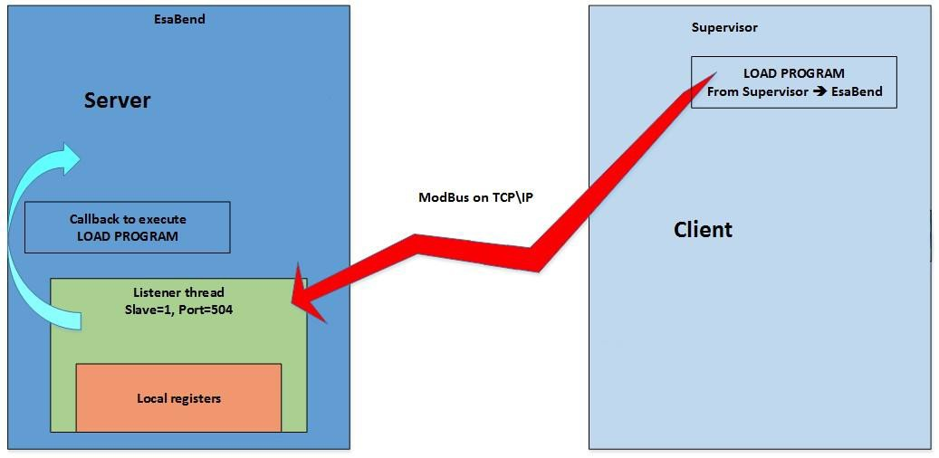

Binding from\to ModBus register ena EsaBend cnc shared memory register
The binding from\to ModBus register ena EsaBend cnc shared memory register mapped in C:\Esabend\Kvara\Exe\NewXMLModBus\ServerModbus.xml file.
For example:
- the bending angle of actual step in shared memory is in “progS.angyaS” and in “1253-1256” ModBus register; the binding in ServerModbus.xml file is in input ModBus are:
<Field Priority=0 Size=4>
<MbAddr>1253</MbAddr>
<ShAddr>progS.angyaS</ShAddr>
</Field>
- the command operating code of EsaBend IoT protocol in shared memory is in “EBCS.wCommandFC” and in “1” ModBus register; the binding in ServerModbus.xml file is in output ModBus are
<Field Priority=0 Size=1>
<MbAddr>1</MbAddr>
<ShAddr>EBCS.wCommandFC</ShAddr>
</Field>

Mapping

Address Modbus = number of ModBus register to read EsaBend data, write data to EsaBend and give commands to Esabend

Description = description of the data read or written or of the command executed

N.Register 16 bit = number of ModBus register

Client Output:

Address Modbus | N.Register 16 bit | Description

0 | 1 | Strobe selection of operating modes,  BIT0 Editor BIT1 Manual  BIT2 Semi-automatic BIT3 Automatic
1 | 1 | BIT0 strobe command
2 | 2 | Command opcode
4 | 1 | Given if type byte
5 | 1 | Given if type word
6 | 1
7 | 2 | Given if type dword
9 | 4 | Dato se tipo double
53 | 40 | Given if type string

Output EsaBend Server:

Address Modbus | N.Register 16 bit | Description
1024 | 2 | Error code
1026 | 100 | Error description header
1126 | 100 | Error description
1226 | 1 | Acknowledgement operative modes:  BIT0 Editor BIT1 Manual  BIT2 SemiAutomatic  BIT3 Automatic
1227 | 1 | Active operating mode: BIT0 Editor mode active BIT1 Manual mode active  BIT2 Semiautomatic mode active BIT3 Automatic mode active
1228 | 1 | Windows popup error code
1229 | 2
1231 | 1 | BIT0 acknowledgement  command
1232 | 1 | Type of bend
…. | …. | ….
…. | …. | …
1965 | 82 | Program name

The data referring to the fields of the current bend are mapped from ModBus register 1232 to register 1965

Address Modbus | N.Register 16 bit | Description
…… | ……
1232 | 1 | Type of bend
1233 | 1 | Rotation
1234 | 1 | Number of times the bend must be repeated before passing on to the next one
…. | …. | …
1253 | 4 | Bending angle required
……. | ……
1965 | 82 | Program name

Look in ServerModbus.xml to all bend data mapped in ModBus register.

Command operating codes
COMMAND_WORK_DIR 3001
COMMAND_RESET_WIN_POPUP_ERR 3002
COMMAND_SAVE_PROG 3003
COMMAND_CONNECT_DISAB_MOUSE_MACHINE2 3004
COMMAND_CONNECT_MACHINE2 3005
COMMAND_DISCONNECT_MACHINE2 3006
COMMAND_STOP 3007
COMMAND_START 3008
COMMAND_LOAD_WORK_LIST 3009
COMMAND_DELETE_PROG 3010
COMMAND_COPY_PROG 3011
SHUT_DOWN 3012

COMMAND_NEXT 3013
COMMAND_PREV 3014
COMMAND_NEW_PROG_NUM 3015
COMMAND_SUPPORT 3016
COMMAND_DUTCH 3017
COMMAND_CHANGE_SECTION 3018
COMMAND_INCREMENTAL 3019
COMMAND_COINING 3020
COMMAND_UPDATE_PROG 3021
COMMAND_DELETE_SECTION 3022
COMMAND_CHANGE_PRESS_MODE 3023
COMMAND_ACTBOMB 3024
COMMAND_SAVE_AS_PROG 3025
COMMAND_BUMPING 3026
COMMAND_DEL_BEND 3027
COMMAND_CONIC 3028
COMMAND_NUM_BEND_SEC 3029
COMMAND_LOAD_PROG 3030
COMMAND_LEARN_Y 3031
COMMAND_LEARN_Z 3032
COMMAND_CHANGE_PROGRAM 3033
COMMAND_CHANGE_PROGRAM_BG 3034
COMMAND_CORR_BY_SEC 3035
COMMAND_CORR_BY_PIECE 3036
COMMAND_CHANGE_BEND_METHOD 3037
COMMAND_CHANGE_BEND_METHOD_EQUAL_ANGLES 3038
COMMAND_CHANGE_BEND_METHOD_ALL_PIECE 3039
COMMAND_LEARN_BEND_SENS_ANG 3040
COMMAND_LEARN_BEND_EQUAL_ANGLES_SENS_ANG 3041
COMMAND_CHANGE_OFFSET_POS_PEZZO 3042
COMMAND_CHANGE_OFFSET_POS_PEZZO_BY_SEC 3043
COMMAND_CHANGE_OFFSET_POS_PEZZO_BY_PIECE 3044
COMMAND_RUN_LASERCHECK 3045
COMMAND_INIT_COMM_LASERCHECK 3046
COMMAND_SEND_BEND_PARAM_LASERCHECK 3047
COMMAND_SEND_SET_TOOL_LASERCHECK 3048
COMMAND_SCAN_ANGLES 3049
COMMAND_SEND_SET_LASER_ON_OFF_LASERCHECK 3050
COMMAND_SEND_CONT_MEAS_ON_OFF_LASERCHECK 3051
COMMAND_SET_FRAME_RATE_LASERCHECK 3052
COMMAND_ECO_REQUEST_LASERCHECK 3053
COMMAND_SAUTO_AUTO_GRAFICO 3054
COMMAND_NUM_BEND_SEC_GRAFICO 3055

Command operating codes that change program and bend values
HD_PIECEP 0 // programmed pieces HD_PIECEM 1 // pieces made
HD_MEASURES 11
HD_DEVELOP 12
HD_NAME_PRG 13
HD_ACT_BEND 14
HD_ACT_SECT 15
HD_NOME 16 // program name
HD_NUM_BEND_SEC 17// currently selected bend number HD_NUMDATI 18 // bend data number in double
1000 must be added to the following codes:

PG_TYPE | 1000 |  | // | type of step
PG_ROT | 1001 |  | // | direction of fold
PG_RIP | 1002 |  | // | number of caland step repetitions.
PG_FUN | 1003 |  | // | dword 20 machine functions
PG_NUMDATIB | 1004 |  | // | Number of bend data in bytes
PG_ACCOMP | 1005 |  | // | accompanying speed
PG_THICK | 1006 |  | // | sheet thickness
PG_TBEND | 1007 |  | // | time spent in the fold
PG_CORPIN | 1008 |  | // | correction altitude 180
PG_ANGY1 | 1009 |  | // | angle y1
PG_ANGY2 | 1010 |  | // | angle y2
PG_X1 | 1011 |  |  | // |  | double | axis | x1
PG_X2 | 1012 |  |  | // |  | double | axis | x2
PG_X3 | 1013 |  |  | // |  | double | axis | x3
PG_X4 | 1014 |  |  | // |  | double | axis | x4
PG_Y1 | 1015 |  |  | // |  | double | axis | y1
PG_Y2 | 1016 |  |  | // |  | double | axis | y2
PG_R1 | 1017 |  |  | // |  | double | axis | r1
PG_R2 | 1018 |  |  | // |  | double | axis | r2
PG_R3 | 1019 |  |  | // |  | double | axis | r3
PG_R4 | 1020 |  |  | // |  | double | axis | r4
PG_Z1 | 1021 |  |  | // |  | double | axis | z1
PG_Z2 | 1022 |  |  | // |  | double | axis | z2
PG_Z3 | 1023 |  |  | // |  | double | axis | z3
PG_Z4 | 1024 |  |  | // |  | double | axis | z4
PG_A1 | 1025 |  |  | // |  | double | axis | auxiliary | 1
PG_A2 | 1026 |  |  | // |  | double | axis | auxiliary | 2
PG_A3 | 1027 |  |  | // |  | double | axis | auxiliary | 3
PG_A4 | 1028 |  |  | // |  | double | axis | auxiliary | 4
PG_A5 | 1029 |  |  | // |  | double | axis | auxiliary | 5
PG_A6 | 1030 |  |  | // |  | double | axis | auxiliary | 6
PG_A7 | 1031 |  |  | // |  | double | axis | auxiliary | 7
PG_A8 | 1032 |  |  | // |  | double | axis | auxiliary | 8
PG_CORAY1 | 1033 | // | correction |  | angle y1
PG_CORAY2 | 1034 | // | correction |  | angle y2
PG_CORX1 | 1035 | // | correction |  | x1
PG_CORX2 | 1036 | // | correction |  | x2
PG_CORX3 | 1037 | // | correction |  | x3
PG_CORX4 | 1038 | // | correction |  | x4
PG_CORY1 | 1039 | // | correction |  | y1
PG_CORY2 | 1040 | // | correction |  | y2
PG_RINX1 | 1041 | // | retract x1

PG_RINX2 | 1042 |  | // | retract | x2
PG_RINX3 | 1043 |  | // | retract | x3
PG_RINX4 | 1044 |  | // | retract | x4
PG_VELW | 1045 |  | // | working | speed
PG_TCP |  | 1046 | // | step change time
PG_PMS |  | 1047 | // | top dead center
PG_NSTAZ |  | 1048 | // | station number
PG_CSENS |  | 1049 | // | flag sensor
PG_SENS1 |  | 1050 | //
PG_SENS2 |  | 1051 | //
PG_SENS3 |  | 1052 | //
PG_SENS4 |  | 1053 | //
PG_SENS5 |  | 1054 | //
PG_SENS6 |  | 1055 | //
PG_METODO |  | 1056 | //
PG_SA |  | 1057
PG_SB |  | 1058 | //
PG_SC |  | 1059 | //
PG_SD |  | 1060 | //
PG_SE |  | 1061 | //
PG_SF |  | 1062
PG_ALTALETTA |  | 1063
PG_NEW5 |  | 1064
PG_NEW6 |  | 1065
PG_NEW7 |  | 1066
PG_NEW8 |  | 1067
PG_NEW9 |  | 1068
PG_GEN_B1 |  | 1069
PG_GEN_B2 |  | 1070
PG_GEN_B3 |  | 1071
PG_GEN_B4 |  | 1072
PG_GEN_B5 |  | 1073
PG_GEN_B6 |  | 1074
PG_GEN_B7 |  | 1075
PG_GEN_B8 |  | 1076
PG_GEN_B9 |  | 1077
PG_GEN_D1 |  | 1078
PG_GEN_D2 |  | 1079
PG_GEN_D3 |  | 1080
PG_GEN_D4 |  | 1081
PG_GEN_D5 |  | 1082
PG_GEN_D6 |  | 1083
PG_GEN_D7 |  | 1084
PG_GEN_D8 |  | 1085
PG_GEN_D9 |  | 1086
PG_SPEED_DEC_LC |  | 1087
PG_DEC_DISTANCE_LC |  | 1088
PG_FIN_BEND_STATUS_LC | 1089
PG_Y1PERDEG_LC | 1090
PG_Y2PERDEG_LC | 1091
PG_SB_Y1_LC | 1092
PG_SB_Y2_LC | 1093
PG_ANGY1_FIN_LC | 1094
PG_ANGY2_FIN_LC | 1095
PG_FORCE_MIS_LC | 1096
PG_POSY1_FIN_LC | 1097
PG_POSY2_FIN_LC | 1098
PG_DB_NUM_STOP_LC | 1099
PG_DB_QTA_PCL_LC | 1100
PG_SB_IMG100 | 1101

PG_WARP_IMG100 | 1102
PG_CONFIDENCE_IMG100 | 1103
PG_NUM_TENTA_IMG100 | 1104
PG_METODO_IMG100 | 1105
PG_TOLL_IMG100 | 1106
PG_PREBEND_IMG100 | 1107
PG_ANG_FIN_IMG100 | 1108
PG_ANG_PRE_B_IMG100 | 1109
PG_VEL_SAL_IMG100 | 1110
PG_DIE | 1111
PG_PUNCH | 1112
PG_SEL_PUNTI_MISURA_LC | 1113
PG_QTA_PNT_MIS_Y1_LC | 1114
PG_QTA_PNT_MIS_Y2_LC | 1115
PG_QTA_PNT_MIS_YB_LC | 1116
PG_QTA_PARCH_LASER_LC | 1117
PG_SCAN_ANGLE_Y1_LC | 1118
PG_SCAN_ANGLE_Y2_LC | 1119
PG_NUM_NO_MATCH_Y1_LC | 1120
PG_NUM_NO_MATCH_Y2_LC | 1121
PG_ANGLE_Y1_FRONT_LC | 1122
PG_ANGLE_Y1_BACK_LC | 1123
PG_ANGLE_Y2_FRONT_LC | 1124
PG_ANGLE_Y2_BACK_LC | 1125
PG_PREBEND_PMI | 1126
PG_DIE_HOLDER 1127
PG_INTERMEDIATE 1128
PG_PMI_AFTER_PREBEND 1129
PG_LAB_MIN |  |  | 1130
PG_AREA_SIC_X |  |  | 1131
PG_AREA_SIC_R |  |  | 1132
PG_SENS_PRES_BOMB_ATT 1133
PG_SENS_PRES_FIND_MAX 1134
PG_SENS_PRES_FIND_SPESS |  | 1135
PG_WIDTH 1136
PG_V_DIE 1137
PG_WIDTH_V_DIE 1138
PG_FORCE 1139
PG_CROWNING 1140
PG_MUTEPOINT 1141
PG_INNER_RADIUS 1142
PG_NAME_MATERIAL 1143
PG_NUM_MATERIAL 1144
PG_RESISTANCE 1145
PG_YB 1146
PG_CORYB 1147
PG_QTA_PARCH_LASER_DX_LC 1148
PG_SENS_ATTIVI 1149
PG_PMI_AFTER_PREBEND_Y2 1150
PG_ROT1 |  |  | 1151
PG_ROT2 |  |  | 1152
PG_ROT_VEL 1153
PG_COR_ROT 1154
PG_ANGY3 |  | 1155 | // angle y3
PG_ANGY4 |  | 1156 | // angle y4
PG_Y3 |  | 1157 | // double axis y3
PG_Y4 |  | 1158 | // double axis y4
PG_CORY3 |  | 1159 | // correction y3
PG_CORY4 |  | 1160 | // correction y4
PG_ROT_PUNCH 1161

PG_ROT_DIE 1162
PG_OFFSET_POS_PEZZO 1163
PG_CORR_ANG_Y1_LC 1164
PG_CORR_ANG_Y2_LC 1165
PG_CORR_ANG_YB_LC 1166
PG_CORR_QTA_PNT_MIS_Y1_LC 1167
PG_CORR_QTA_PNT_MIS_Y2_LC 1168
PG_CORR_QTA_PNT_MIS_YB_LC 1169

Protocol

Client Command protocol:
- Write data to one or more ModBus registers address 4 or 5 or 6 or 7 or 9 or 53 (depending on the command)
- Write command opcode in ModBus register address 2
- Write strobe command (bit0 to 1) in ModBus register address 1 (set strobe)
- Wait acknowledgment command (bit0 to 1) in ModBus register address 1231 (wait acknowledgment go 1)
- Write strobe command (bit0 to 0) in ModBus register address 1 (Reset strobe)
- Wait acknowledgment command (bit0 to 0) in ModBus register address 1231 (wait acknowledgment go 0)
The ModBus registers address 4 or 5 or 6 or 7 or 9 or 53 to write to depends on the data type For program and bend data, refer to the "Current bend data" chapter.

Client operating mode selection protocol
The EsaBend operating modes that can be selected from the protocol are: Settings, Manual, Semi-Automatic, Automatic.
- Write to 1 of the appropriate bit depending on the operating mode to be selected in ModBus register address 0 (set strobe)
- Wait acknowledgment operatign mode for the appropriate bit (bitXX to 1) in ModBus register address 1226 (wait acknowledgment go 1)
- Write to 1 of the appropriate bit depending on the operating mode to be selected in ModBus register address 1 (Reset strobe)
- Wait acknowledgment operating mode for the appropriate bit (bitXX to 0) in ModBus register address 1226 (wait acknowledgment go 0)

Example of Automatic Operating Mode selection
- Write bit3 to 1 in ModBus register address 0 (set strobe)
- Wait for bit3 to 1 in ModBus register address 1226 (wait acknowledgment go 1)
- Write bit3 to 0 in ModBus register address 0 (Reset strobe)
- Wait for bit3 to 0 in ModBus register address 1226 (wait acknowledgment go 0)

Example of Load Program command
NOTE: Before sending the load program command, select the Editor operating mode.
- Write program name to ModBus registers address 53-63
- Write command opcode 3030 in ModBus register address 2
- Write strobe command (bit0 to 1) in ModBus register address 1
- Wait acknowledgment command bit0 to 1 in ModBus register address 1231
- Write strobe command bit0 to 0 in ModBus register address 1
- Wait acknowledgment command bit0 to 0 in ModBus register address 1231

Example changes Pieces to Make
NOTE: Before sending data, select the Editor operating mode.
- Write pices to make to ModBus registers address 7
- Write command opcode 0 in ModBus register address 2
- Write strobe command bit0 to 1 in ModBus register address 1
- Wait acknowledgment command bit0 to 1 in ModBus register address 1231
- Write strobe command bit0 to 0 in ModBus register address 1
- Wait acknowledgment command bit0 to 0 in ModBus register address 1231

Example change Angle
NOTE: Before sending data, select the Editor operating mode.
- Write angle to ModBus registers address 9
- Write command opcode 1009 in ModBus register address 2

- Write strobe command bit0 to 1 in ModBus register address 1
- Wait acknowledgment command bit0 to 1 in ModBus register address 1231
- Write strobe command bit0 to 0 in ModBus register address 1
- Wait acknowledgment command bit0 to 0 in ModBus register address 1231

Debug
The shared memory registers involved for the protocol is defined in defcn_EBCS and to debug the protocol signals just use TksShare.exe and connect the shared memory directors listed below:

//EsaBendClientServer typedef struct {
//From Client to Server
word wMode; // Strobe selection of operating modes

word wCommandFC; // strobe command dword dwCodeFC; // Command opcode byte byDataFC; // Given if type byte
word wDataFC; // Given if type word

word wDataFC_b;
dword dwDataFC; // Given if type dword

double dDataFC; // Given if type double

string strDataFC[40]; // Given if type string
.
.
.
//From Server to Client
dword dwErrorCode; // Error code
string strErUITextA[200]; //Error description header

string strErUITextB[200]; // Error description

word wAckMode; // Acknowledgement operative modes
.
word wAckCommandFS; acknowledgement command
} S_EBCS;
.
S_EBCS EBCS;

the mapping ModBus register and shared memory register is:

Client Output:

Address Modbus | N.Register 16 bit | Registers in shared memory | Description
0 | 1 | EBCS.wMode | Strobe selection of operating modes,  BIT0 Editor BIT1 Manual  BIT2 Semi-automatic BIT3 Automatic
1 | 1 | EBCS.wCommand | BIT0 strobe command
2 | 2 | EBCS.dwCodeFC | Command opcode
4 | 1 | EBCS.byDataFC | Given if type byte
5 | 1 | EBCS.wDataFC | Given if type word
6 | 1 | EBCS.wDataFC_b
7 | 2 | EBCS.dwDataFC | Given if type dword
9 | 4 | EBCS.dDataFC | Dato se tipo double
53 | 40 | EBCS.strDataFC[40] | Given if type string

Output EsaBend Server:

Address Modbus | N.Register 16 bit | Registers in shared memory | Description
1024 | 2 | EBCS.dwErrorCode | Error code
1026 | 100 | EBCS.strErUITextA[200] | Error description header
1126 | 100 | EBCS.strErUITextB[200] | Error description
1226 | 1 | EBCS.wAckMode | Acknowledgement operative modes:  BIT0 Editor BIT1 Manual  BIT2 SemiAutomatic  BIT3 Automatic
1227 | 1 | EBCS.wActualMode | Active operating mode: BIT0 Editor mode active BIT1 Manual mode active  BIT2 Semiautomatic mode active BIT3 Automatic mode active
1228 | 1 | EBCS.wErrData | Windows popup error code
1229 | 2 | EBCS.dwErrValue
1231 | 1 | EBCS.wAckCommandFS | BIT0 acknowledgement  command
1232 | 1 | progS.typeS | Type of bend
…. | …. | …. | ….
…. | …. | …. | …
1965 | 82 | nprS | Program name

To debug the protocol .

Timed reading to avoid disconnection
In the event of a lack of communication, the server disconnects but to avoid this, the client simply needs to read an input register every 10 seconds.

Disable commands and data from supervisor
Reception of commands or data from the supervisor is disabled (EsaBend does not execute the command and does not modify the data) if bit C44.15 is set to 1 or the "Disable commands and data from supervisor" parameter is set on the IoT page:
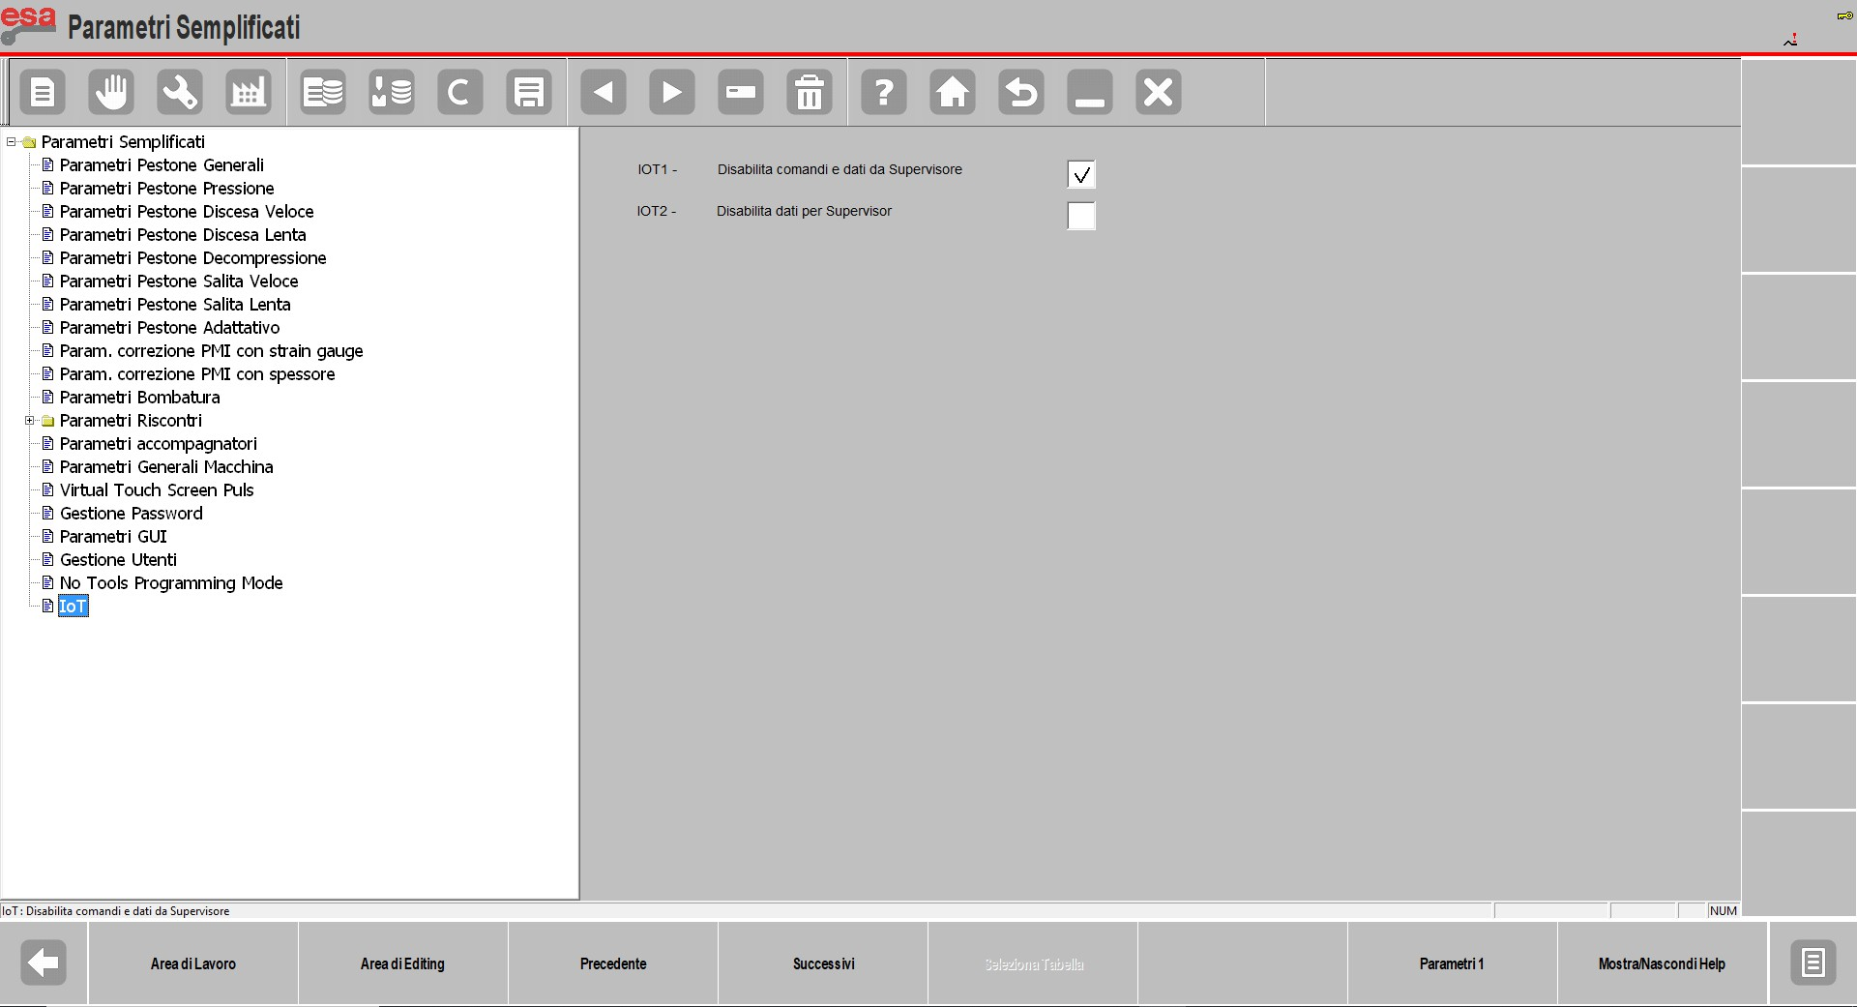

Disable data for supervisor
Sending data to the supervisor is disabled (EsaBend does not refresh the data for the supervisor) if bit C44.16 is set to 1 or the "Disable data for supervisor" parameter is set on the IoT page:
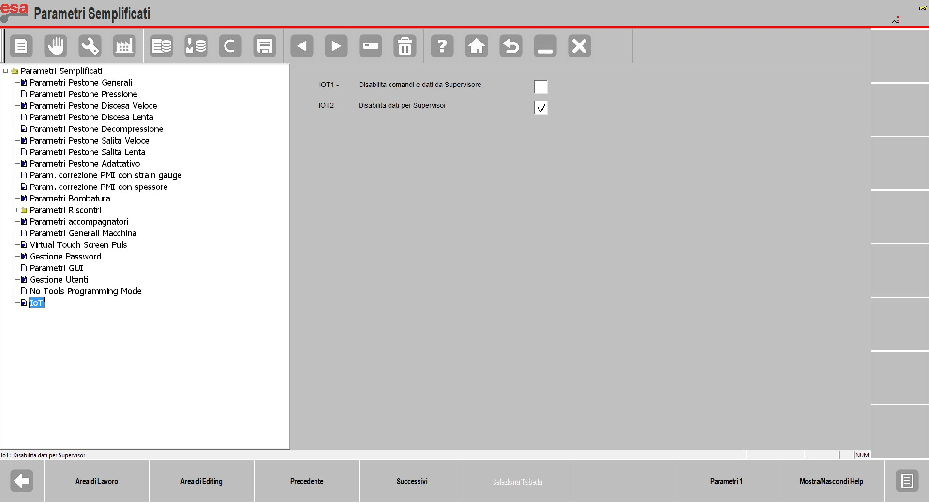

Data format used in ModBus protocol

Formato WORD 16bit
The 16bit format is the minimum format used by the ModBus protocol; the byte order used by the modbus protocol is big-endian, from the most significant byte to the least significant byte.

Formato DWORD 32bit
32bit data is stored in two consecutive registers starting from the even address.

 | Address
HIGH REGISTER | 0
LOW REGISTER | 1

The byte order used by the ModBus protocol is big-endian, from most significant to least significant byte.

String format
String format fields are stored on consecutive registers, two bytes for each register; the maximum limit of registers read in block is 125 and the maximum limit of registers written in block is 123. The table below shows an example of how a 10 character ASCII string will be stored.
Es: String “0123456789”

 | Address | Value
REG. | 0 | 0x3031
……... | 1 | 0x3233
…….. | … | 0x3435
 |  | 0x3637
REG. | 4 | 0x3839

The byte order used by the Modbus protocol is big-endian, from most significant to least significant byte.

Log
The feature allows you to trace commands and data coming from an external supervisor

Enable
In the Ppg.ini file under the [APP] section add the keys IOT_LOG=1
LOG_FILE=1

Log file
In
C:\KVFILE\setupkv\ EsaBendLog.txt there is log file
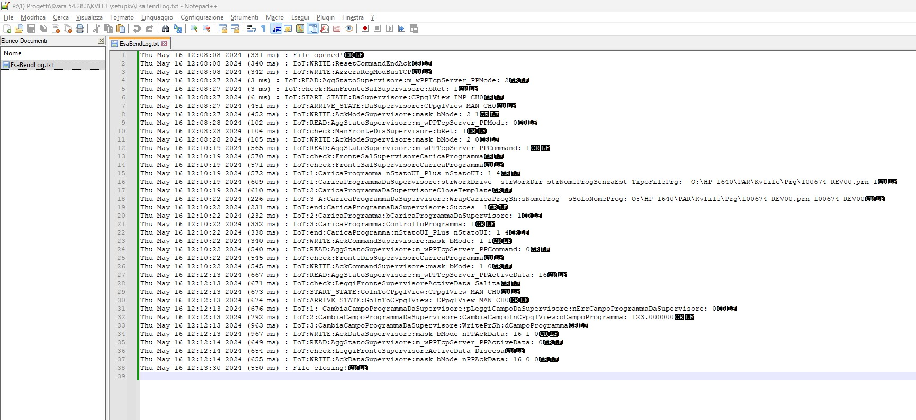

The Log file is reset every time EsaBend is restarted; in case of malfunction, copy and send EsaBendLog.txt to Esautomotion BEFORE restarting EsaBend.

Test con Client EsaBendClient.exe
To perform connection, command, data writing and data reading tests from clients, the EsaBendClient.exe application can be used, see EsaBendClient- Rev.0 - ENG.pdf document.

EsaBend ModBusTCP connection configuration

Description
The connection configuration between supervisor and Esabend ModBusTCP server is in the ServerModBus.XML file; the default written configuration is localost (127.0.0.1), i.e. the supervisor on the same PC as EsaBend. If you want to modify it, you need to change the ServerModBus.XML file and the window network configuration.

Supervisor PC physical connection with EsaBend PC

Direct connection
Corporate Network
CNC

EsaBend PC

Supervisor PC

    - For EsaBend PC configuration use the following IP addres, IP address: 172.16.0.51, Subnet mask: 255.255.0.0
    - EsaBend PC in C:\Kvara\exe\ServerModBus.XML set the key <IPAddr>172.16.0.51</IPAddr>
    - For Supervision PC configuration use the following IP addres, IP address: 172.16.0.50, Subnet mask: 255.255.0.0

To configure: Start->Network Connections (Fig.1)
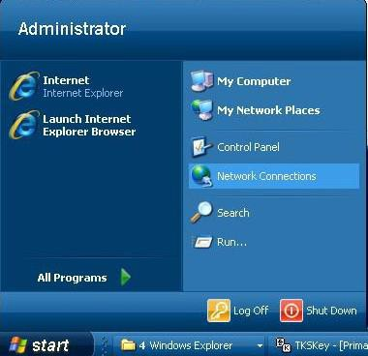
Fig.1
Right click on Len3 (or Len 2) Fig.2
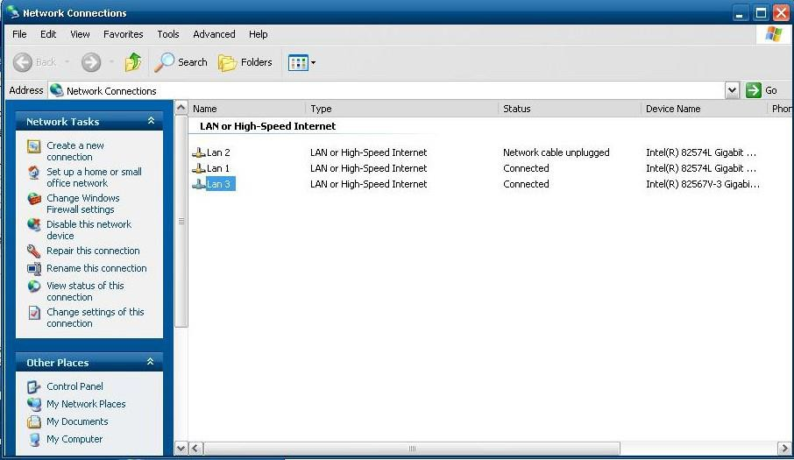
Fig.2

General, Internet Protocol (TCP\IP), Properties (Fig.3)
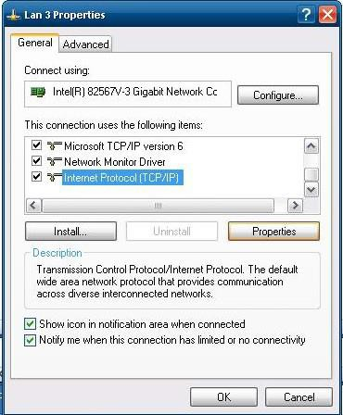
Fig.3

- For EsaBend PC configuration use the following IP addres, IP address: 172.16.0.51, Subnet mask: 255.255.0.0 (Fig.4)
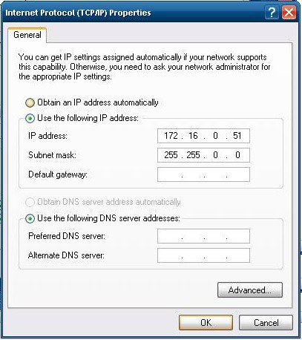

Fig.4

- For Supervision PC configuration use the following IP addres, IP address: 172.16.0.50, Subnet mask: 255.255.0.0 (Fig.5)
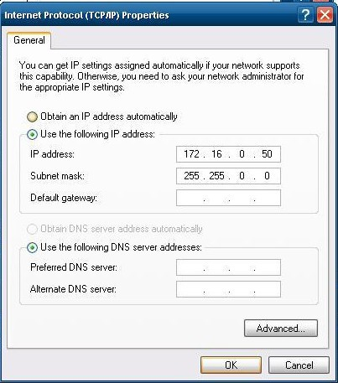

Fig.5

  - Direct connections with hub

Corporate Network

Supervisor PC
CNC

EsaBend PC

- For EsaBend PC configuration use the following IP addres, IP address: 10.10.51.99, Subnet mask: 255.255.0.0

HUB
- EsaBend PC in C:\Kvara\exe\ServerModBus.XML set the key <IPAddr>10.10.51.99<IPAddr>
- For Supervision PC configuration use the following IP addres, IP address: 10.10.51.51, Subnet mask: 255.255.0.0

  - Connection with corporate network

Corporate Network

Supervisor PC
CNC

EsaBend PC

To set the correct IP in C:\Kvara\exe\ServerModBus.XML check:
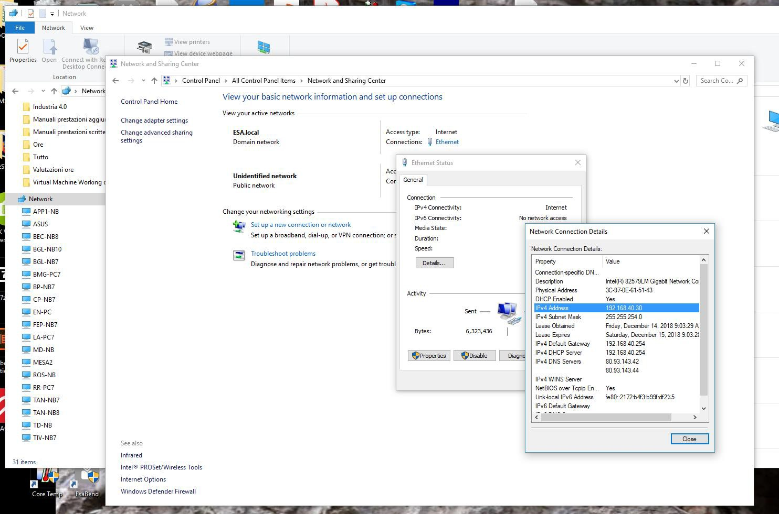

    - For EsaBend PC configuration use the IP addres, where the first two numbers of the address are the same corporate network address. This static IP must be set also in the corporate server (ex. 192.168.40.30)
    - In EsaBend PC in C:\Kvara\exe\ServerModBus.XML set the key <IPAddr>192.168.40.30<IPAddr>
    - The Supervision PC configuration IP addres is dynamically assigned by the corporate server
    - The Supervisor Client must connect (in this example) 192.168.40.30

Antivirus
Many antiviruses block the channel that uses ModBusTCP so it is necessary to either configure the antivirus so that it does not block communication or completely stop the antivirus.
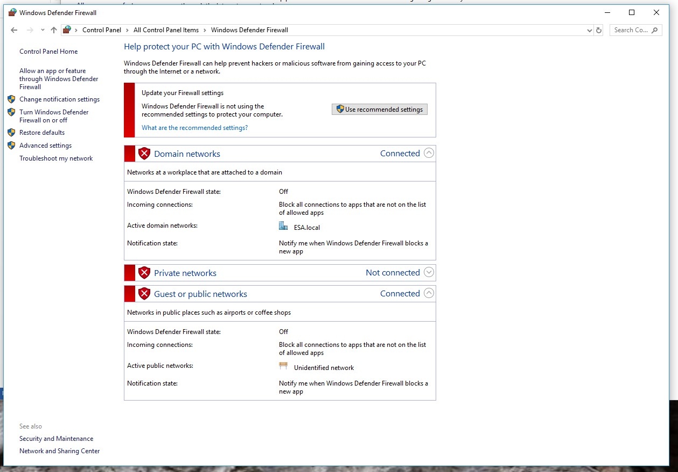
Also disable the "Windows Defender Fire Wall" on the PC where EsaBend resides:

15. Directly automatically
When loading the program from the supervisor, EsaBend goes directly into automatic mode. If you don't want to log in automatically, you need to set the key below in PPG.ini [ModBusTCPClient]
NO_AUTO=0

Andrea Turchi

Rev.2 09/08/2024 Rev.1 08/05/2024 Rev.0 26/06/2024

